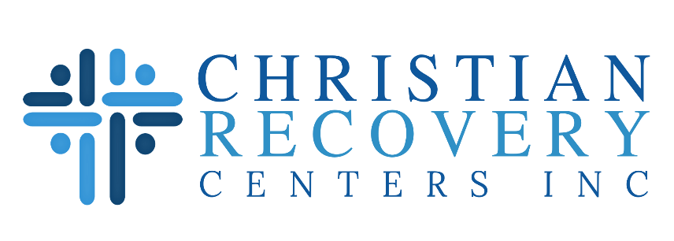

Job Title: Director of Development

Reports To: CEO

Supportive Staff: Brand Manager (.5 FTE), Major Gifts Officer (.5 FTE), Outreach & Logistics Coordinator, Community Relations Specialist

Job Status: Full-time, regular – Exempt

Expected Hours: 45 Hours Weekly

Job Summary: The Director of Development is responsible for the development, implementation, coordination, and expansion of the Christian Recovery Centers’s volunteer/donor relations program, which consists of direct mail, monthly giving program, major donors, planned giving, foundation and corporate funding, and special events. This position works closely with the CEO to integrate all elements of the Mission’s fundraising functions with our Strategic Plan; successfully meet annual revenue goals; and integrate the vision, core values and culture of CRCI.

**Overview:** As a growing 501(c)(3), nonprofit organization, CRCI is always looking for new talented individuals who can be an addition to its efforts. It is CRCI Management's desire that each person involved with the organization has a burden for the lost, the sick, and the suffering. CRCI is a Christian agency that follows Christian morals and ideals. Employees are asked to agree to these standards and actively display a lifestyle of Christian Conduct along with a profession of faith.

Agreed Upon Job Duties and Responsibilities:

* Develop and maintain a strategic plan for all aspects of Development and public relations efforts.
* Develop and implement a strategic plan for all aspects of volunteer and community engagement that moves individuals, groups, and corporations from volunteers to donors. This includes:

o Church engagement, which involves both volunteers and fundraising.

o Corporate and small business relationships that involves both volunteers and fundraising.

o Oversee community engagement for external events (mission fairs, corporate fairs, 3rd party fundraising efforts, etc.) and internal events including holiday meals, donor dinners, volunteer dinners, fundraising events, etc.

* Develop, implement, and track specific programs that will identify, cultivate, solicit, involve, and steward new leadership donors from individuals, churches, and foundations. Create and maintain high levels of donor relationships that will better serve to solidify stronger ties to the donor.
* Supervise and assist in all major gift Advancement activities, including work with individuals, corporations, foundations, and churches. Identify, cultivate, and solicit gifts from assigned individuals and selected corporations and foundations by building long-term relationships through personal visits, phone and written correspondence.
* Oversee the computer donor system so that all mailings are ready to be mailed at the scheduled times, records are updated daily, and that research is completed for timely field calls. This also includes developing a meaningful mailing list for continued financial support.
* Develop and implement planned giving programs by building awareness among existing and prospective individual donors of planned gift options and benefits.
* Capital Campaigns

a. Oversee the coordination of Capital Campaigns in conjunction with the CEO. This involves identifying prospects, arranging meetings with prospects, and overseeing special events for the campaign.

b. Prepare proposals for potential individual donors, foundations, churches, and corporations.

c. Develop the necessary materials for the campaign

* Provide Executive leadership and support so that CRCI is able to achieve its goals.
* Complete Stewardship Reports for project based giving
* Supervises, manages and motivates Development staff and develops the annual department objectives, budget, and work schedule.
* Oversee Grant Writing program and ensure information provided to the Grants committee is accurate and up to date.
  + Ensure Grant reporting is completed in a timely manner

**Fundraising Events**

* Approve and coordinate the ministries involvement with special fundraising projects sponsored by interested groups or individuals. Oversee special fundraising and other cultivation events.
* Create annual calendar for fundraising events
* Work with Fundraising committee to execute events
  + Focus on events ROI and budget controls

**Marketing**

* Oversee team responsible for Brand recognition and agency promotion of services including Workforce Redevelopment Programs
  + Ensure consistent marketing and branding
* Supervise and assist with all public relations, media relations, branding, and marketing efforts to enhance community awareness, understanding, perception, involvement and financial support of CRCI. Develop and implement communication and marketing strategies to support leadership giving. Ensure High Website performance.

**Volunteer Coordination**

* effectively communicate with high impact volunteers and community partners to ensure they're active engagement and support
* solicit for CRCI needs at community functions
* Coordinate with program staff to strategically place willing volunteers in key areas of need
  + maintain and update list of active & on assignment volunteers
  + Maintain an ongoing list of Volunteer responsibilities
* Create new church and community partners and encourage interaction with program staff

## Qualifications

## *Christian Recovery Centers Requirements:*

* Have a desire to serve the Lord through widely varied responsibilities to advance ministry to the sick and suffering.

## *Required Skills/Abilities:*

* Have good communication skills both written and verbal.
* Have a working knowledge of planned giving, grant writing, government relations, digital strategies and marketing.

## *Education and Experience:*

* Minimum of 5 years of proven success in nonprofit fundraising, with at least 2 years in a leadership role.
* Demonstrated track record of achieving significant fundraising targets and scaling revenue streams.
* Exceptional leadership, communication, and relationship-building skills, with the ability to inspire donors, volunteers, and staff.
* Expertise in brand management, marketing strategy, and leveraging digital tools for fundraising and engagement.
* Strong financial acumen, with experience in budgeting, financial oversight, and strategic planning.
* Passion for the Mission’s work and a commitment to advancing its values and impact.

***Key Competencies:***

* Visionary Leadership and Strategic Thinking
* Relationship Management
* Data-Driven Insights and Analytical Decision-Making
* Collaborative Team Leadership
* Innovative, Forward-Thinking, and Results-Oriented

## *Physical Requirements:*

* Prolonged periods of sitting/standing/kneeling, etc.
* Must be able to operate a vehicle to attend events or other related functions

## *Travel Requirements:*

* Ability to drive to our campuses and meet with donors and attend national conferences and events as needed.